**Student Engagement and Course Performance Analysis Report**

# **Top 5 Insights**

**1. Engagement Varies by Course**

* **Insight**: The courses "DM101" and "WD404" have the highest average engagement times, with students spending more time in these courses compared to others like "PY202" and "UX303." Specifically:
  + **Highest Engagement**: **DM101** with 102.43 minutes on average.
  + **Lowest Engagement**: **PY202** with 93.90 minutes on average.
* **Business Implication**: The significant variation in engagement time across courses suggests that certain courses (e.g., DM101) may require more interaction or be perceived as more engaging. The platform should focus on understanding the specific elements that drive higher engagement in these courses and replicate them in others. For courses with lower engagement (e.g., PY202), the platform could consider redesigning content or incorporating more interactive features to retain user interest.

**2. Age Group Impact on Engagement**

* **Insight**: The analysis of student engagement by age group reveals the following:
  + **Age Group 18-25** has an average engagement time of 100.76 minutes.
  + **Age Group 26-35** follows closely with an average of 95.36 minutes.
* **Business Implication**: Younger students (18-25) are slightly more engaged than the 26-35 age group. This insight can guide marketing efforts, content creation, and course customization. For example, platforms targeting a younger audience could focus on more gamified or interactive learning experiences, while courses aimed at older students might benefit from more professional and structured content formats.

**3. Location-Based Engagement Insights**

* **Insight**: Engagement also varies by location, with the highest engagement time recorded in **Kolkata** (104.38 minutes), followed by **Delhi** (103.30 minutes).
* **Business Implication**: The platform could consider regional differences in content preferences, marketing strategies, or even logistical factors like course availability or connectivity. Kolkata and Delhi being top performers could be a sign of regional demand or specific user preferences that can be further explored to boost engagement in other regions with lower engagement times (e.g., Chennai and Mumbai).

**4. Correlation Between Completion Rate and Feedback Rating**

* **Insight**: The correlation between completion percentage and feedback rating is **-0.052**, which is very weak and negative. This suggests that as students complete more of a course, their feedback rating doesn't necessarily improve. There might be cases where higher completion rates correspond to lower satisfaction levels.
* **Business Implication**: This insight could indicate that students who complete courses in full may be dissatisfied with the content, possibly due to unmet expectations or content quality. The platform should investigate this further by segmenting feedback based on different completion rates to identify areas for improvement in course design, delivery, or support during the learning process.

**5. Top Student Segments Based on Engagement and Satisfaction**

* **Insight**: The analysis of top student segments reveals that the most engaged and satisfied students are:
  + **Student_36** (Time spent: 175 mins, Rating: 5, Age: 25, Location: Chennai)
  + **Student_81** (Time spent: 174 mins, Rating: 4, Age: 24, Location: Bangalore)
  + **Student_64** (Time spent: 173 mins, Rating: 4, Age: 30, Location: Bangalore)
* **Business Implication**: These students represent the ideal profile of highly engaged and satisfied learners. Understanding their behavior can help the platform refine its offerings for other students. The business can create personalized recommendations for similar learners and offer additional incentives (e.g., discounts or badges) to motivate other users to reach similar engagement and satisfaction levels.

# **Data-Driven Recommendations**

**Recommendation 1: Implement Personalization and Adaptive Learning Paths**

* **Objective**: Tailor learning experiences based on student demographics and engagement levels.
* **Key Actions**:
  + **Personalized Learning Paths**: Use student age, location, and previous performance to recommend courses or adjust content delivery.
  + **Dynamic Difficulty Adjustments**: Based on student progress, offer more challenging content or additional resources if a student is struggling.
* **Expected Impact**: Increases engagement by providing content that is better suited to each student's learning style and needs, leading to higher course completion rates.

**Recommendation 2: Gamify the Learning Experience with Rewards for Engagement**

* **Objective**: Increase student motivation and interaction with courses through gamification elements.
* **Key Actions**:
  + **Progress Badges and Leaderboards**: Reward students with badges for course milestones (e.g., completion, high ratings), and create leaderboards to encourage friendly competition.
  + **Interactive Challenges**: Introduce quizzes or real-time challenges with rewards for students who actively participate.
  + **Incentivize Engagement**: Offer real-world rewards (e.g., certificates, discounts) for students who achieve engagement milestones.
* **Expected Impact**: Higher engagement and consistent course completion. Motivates students to stay involved throughout their learning journey.

**Recommendation 3: Optimize Course Content Based on Feedback and Completion Data**

* **Objective**: Continuously improve course content by leveraging student feedback and engagement metrics.
* **Key Actions**:
  + **Analyse Feedback and Completion Data**: Regularly assess student feedback and completion rates to identify areas of improvement (e.g., course difficulty, pacing, interactivity).
  + **A/B Testing**: Test different content formats (videos, quizzes, interactive lessons) and analyse their impact on student engagement.
  + **Real-Time Adjustments**: Implement features that dynamically adjust course content based on real-time data, such as providing additional learning materials when students struggle.
* **Expected Impact**: Ensures that courses meet student expectations, leading to higher satisfaction and reduced dropout rates.

**Visualisations**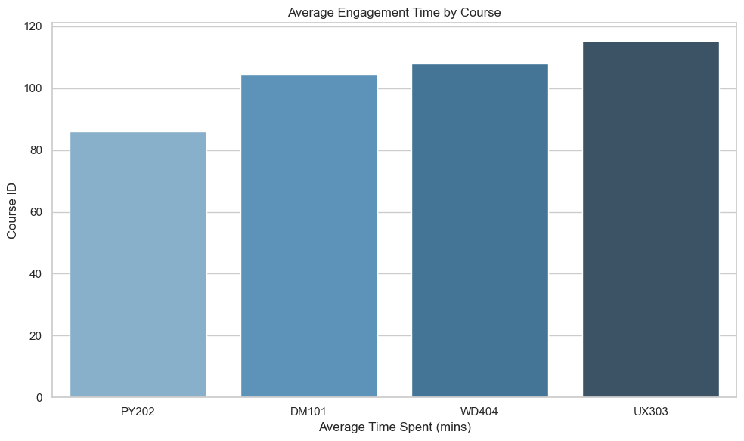

**Box Plot: Time Spent by Age Group**

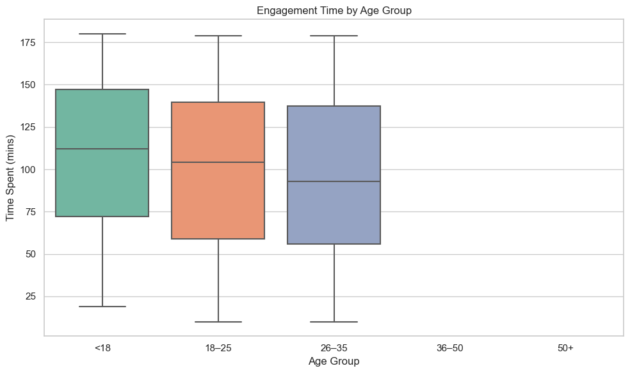

**Box Plot: Time Spent by Age Group**

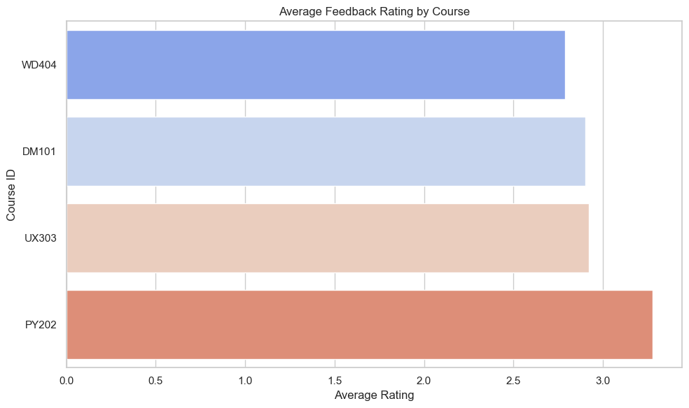

**Bar Chart: Average Feedback Rating by Course**

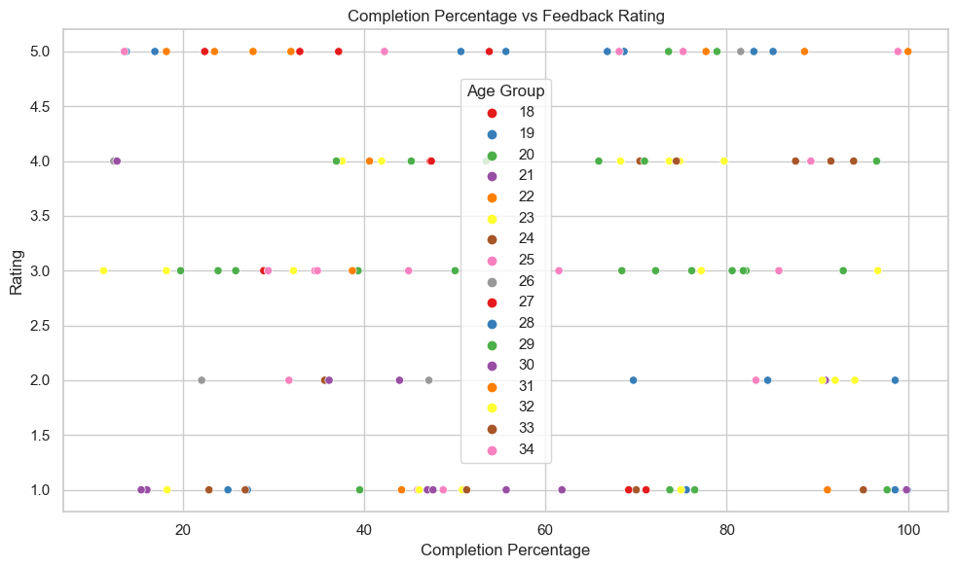

**Scatter Plot: Completion% vs Feedback Rating**

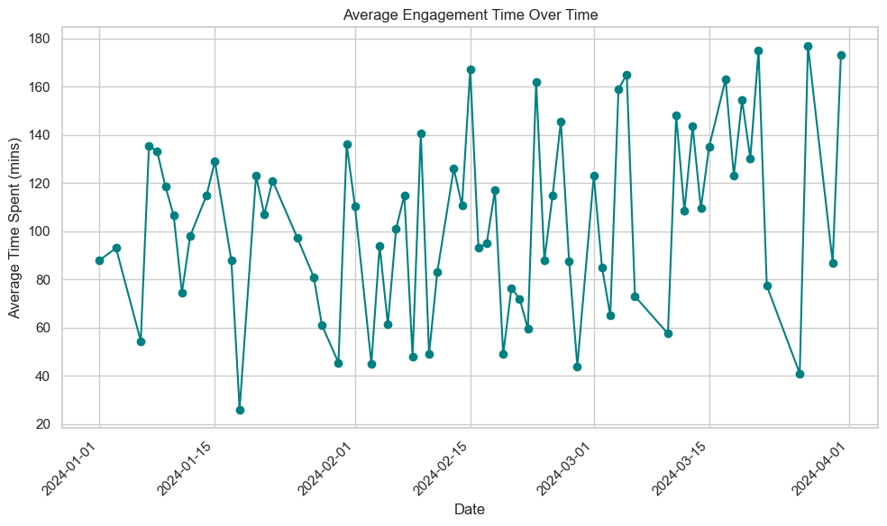

**Line Plot: Average Engagement Over Time**

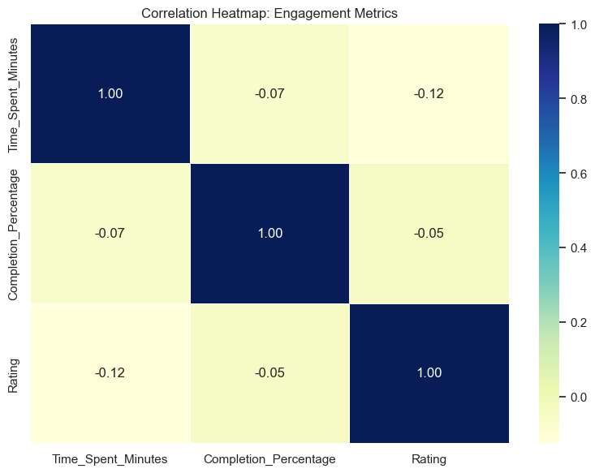

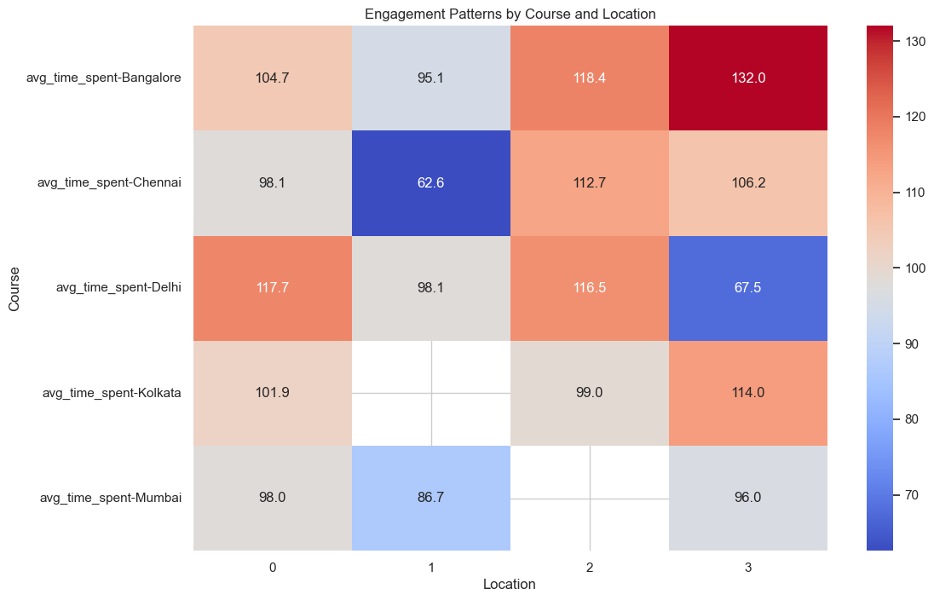**Heatmap of Correlation Between Engagement Metrics**

**Heatmap: Engagement Patterns by Course and Location (Demographic)**